**BATCH 5: 12 to 2 pm**

**ASSIGNMENT NO 1**

ROLL NO:**304316**

Name: Azeesha Ali

Instructor: Mam Anoosh

Practice 1

Q1: Print your name in green?

**Code**

**HTML**

**Output**

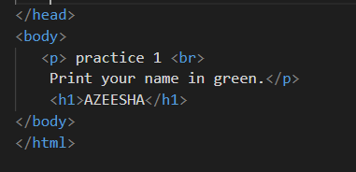

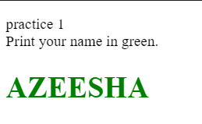

Output

**CSS**

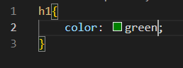

Q2: Print a paragraph that is a description of a book, include the title of the book as well as its author. Names and titles should be underlined, adjectives should be italicized and bolded?

**Code+ Output=**

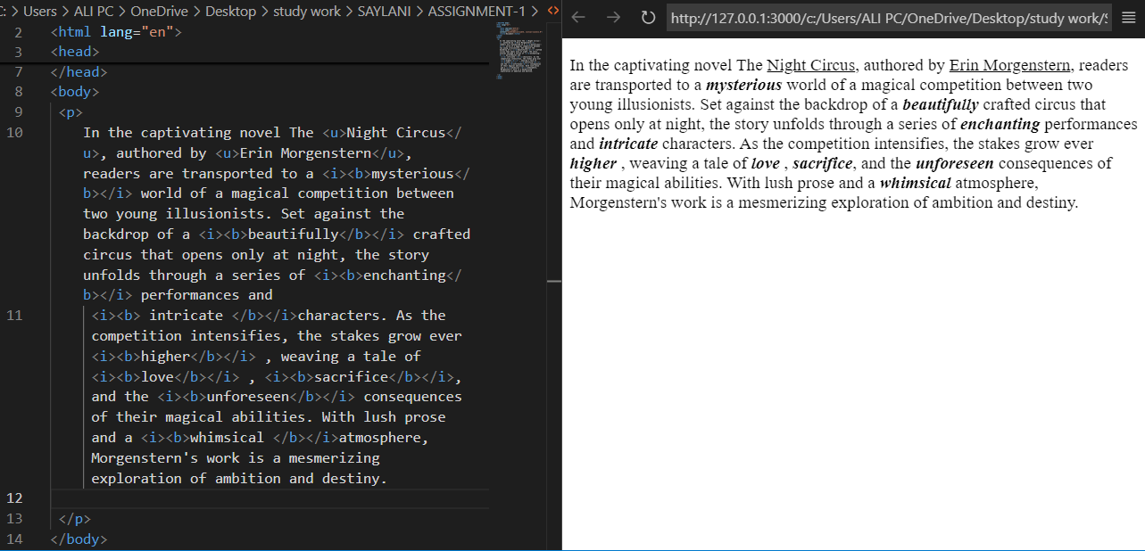

Q3: Print your name to the screen with every letter being a different heading size?

**Html:**

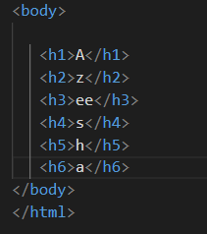

**Output:**

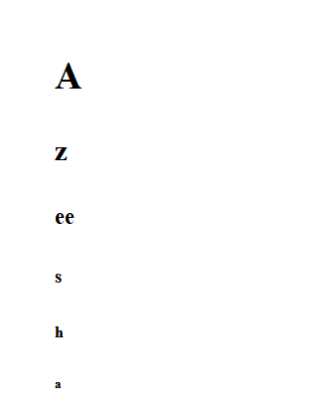

Q4: Create some links to various search engines (google, yahoo, altavista, lycos, etc). Now Use

Image Icons for each link along with Text

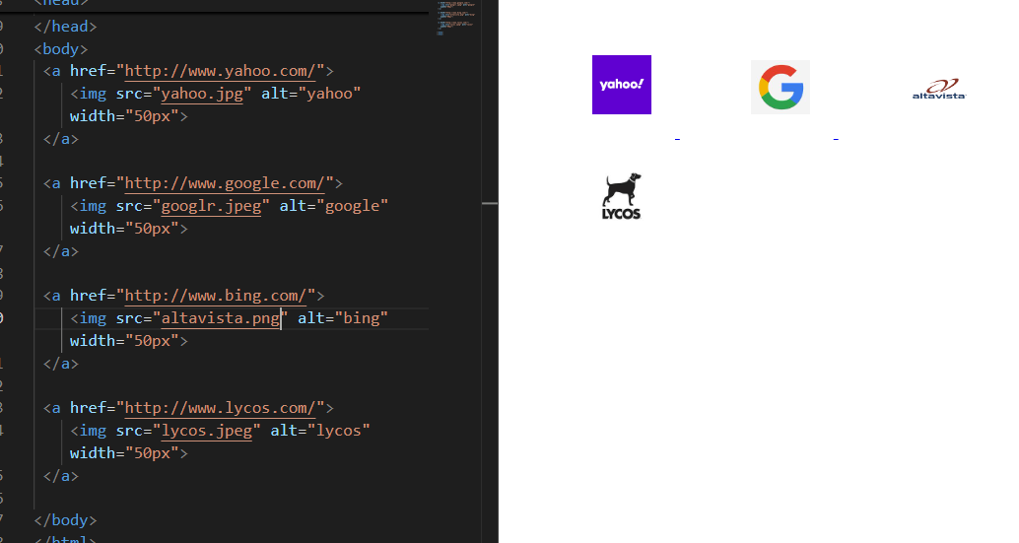

Q5 Create links to five different pages on five different websites that should all open in a new

Window

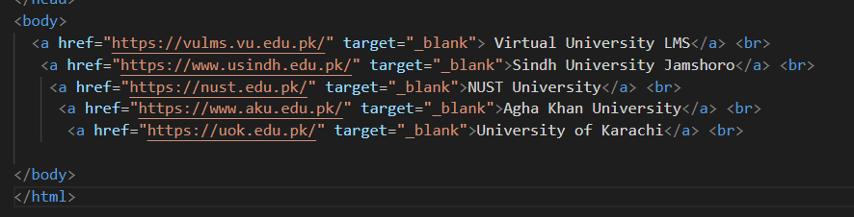



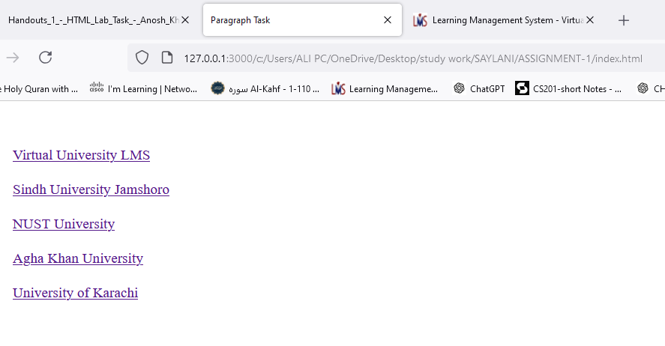

Q6 Create a page with a link at the top of it that when clicked will jump all the way to the bottom of

the page.

**Html + CSS=**

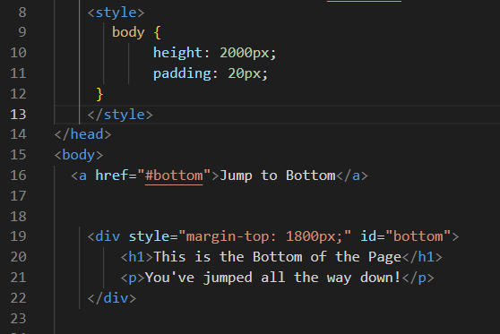

**Output=**can see scroll bar that this link takes down all the way down.

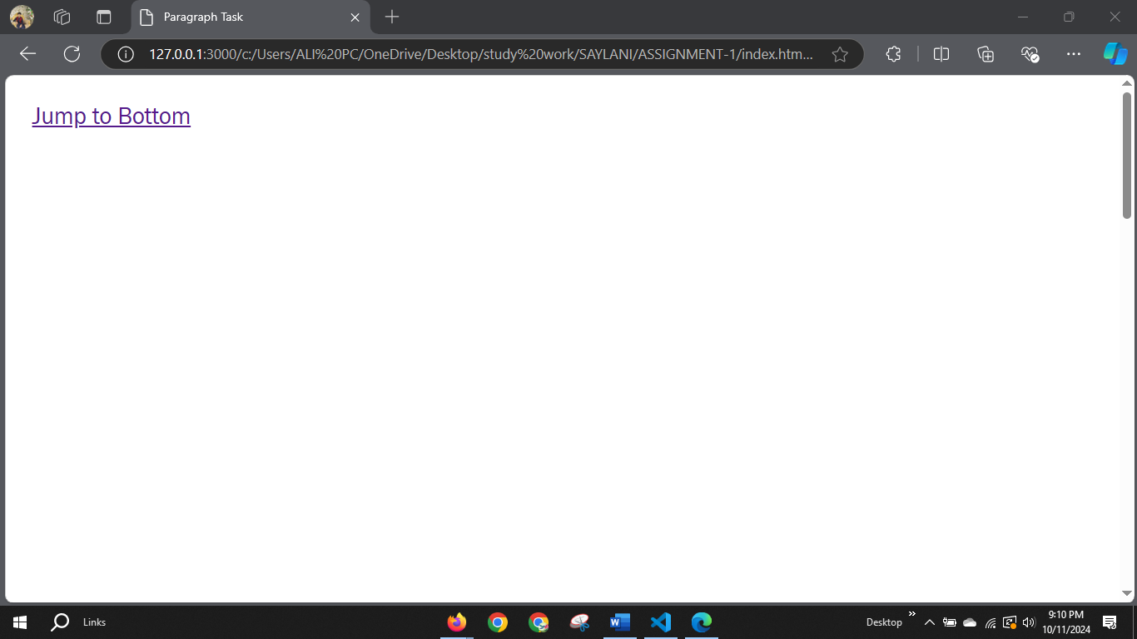

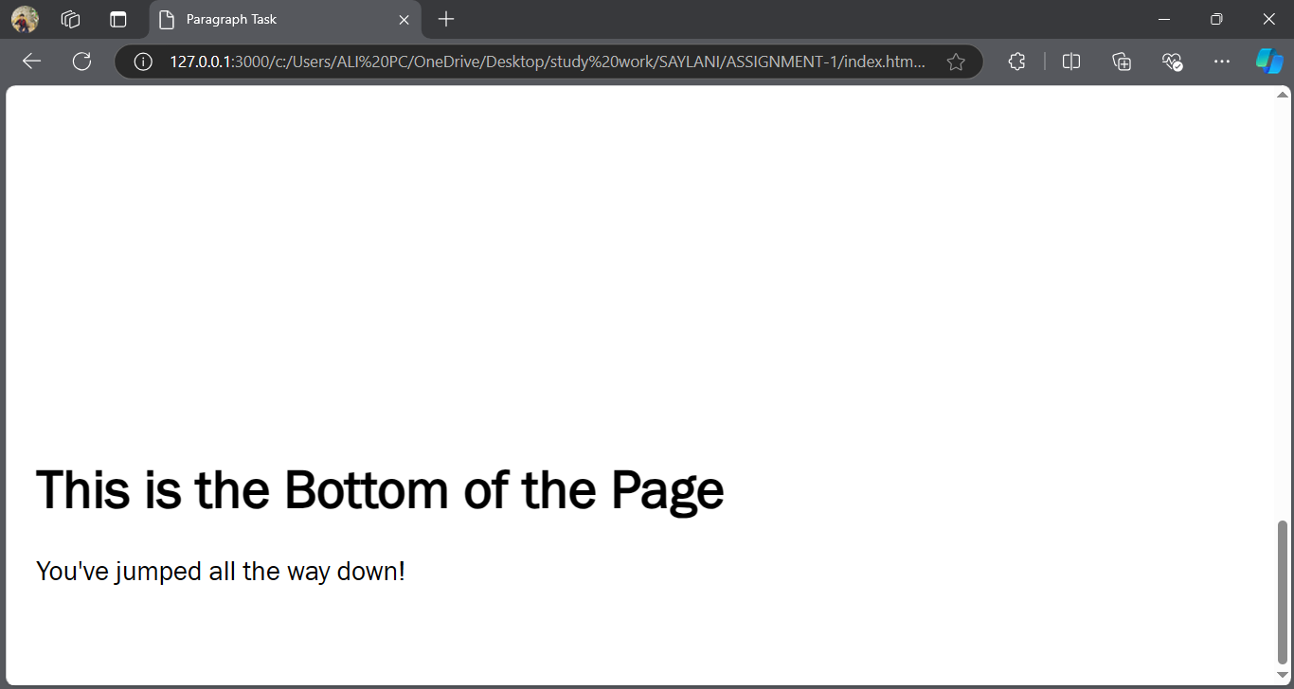

Q7 Display an image that has a border of size 2, a width of 200, and a height of 200

**HTML+CSS=**

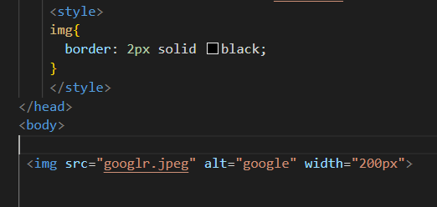

**OUTPUT**

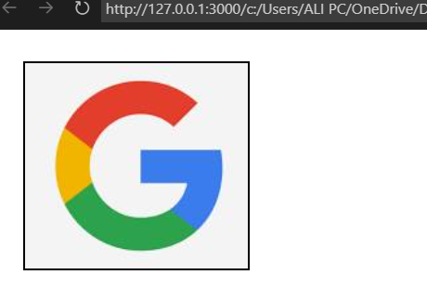

Q8 Display an image that when clicked will link to a search engine of your choice (should be opened

in a new window.

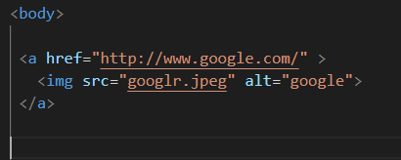

Output

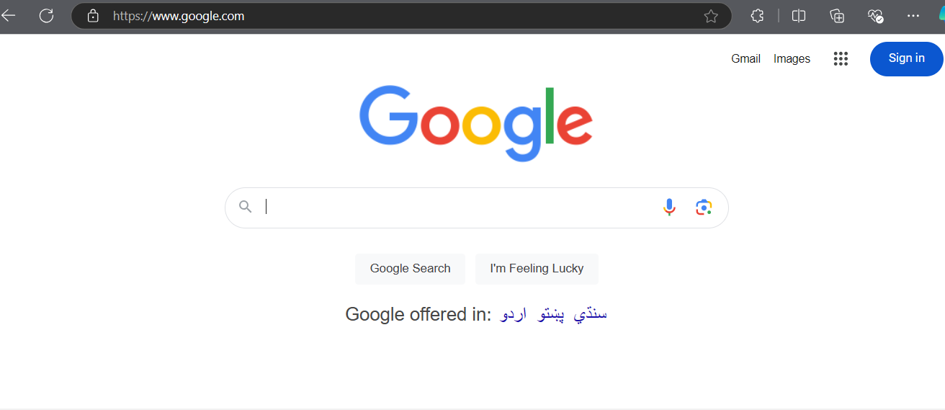

Q9 Display an image that when clicked will link to itself and will display the image in the browser

by itself.

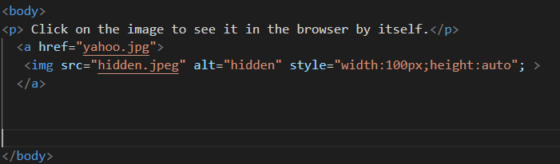

**Output**

After clicking on it, it will open an image separately

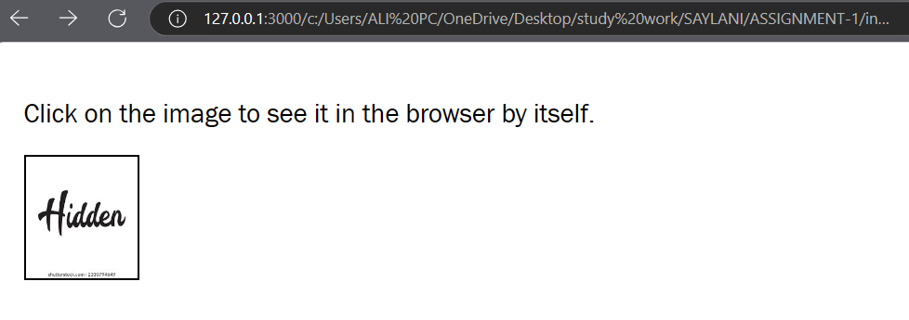

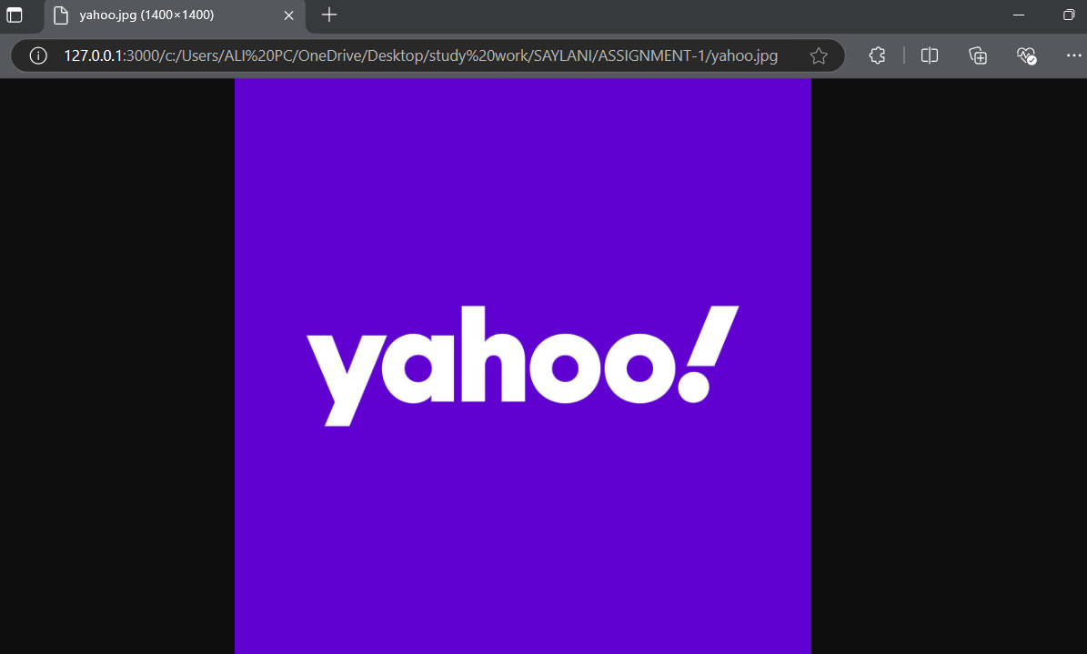

Q10 Display five different images. Skip two lines between each image. Each image should have a

title.

**HTML**

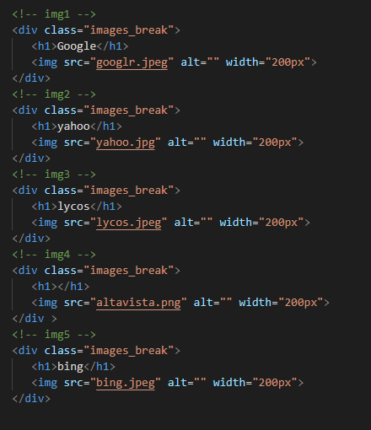

**CSS**

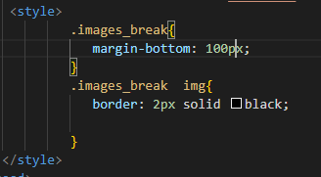

**Output:**

